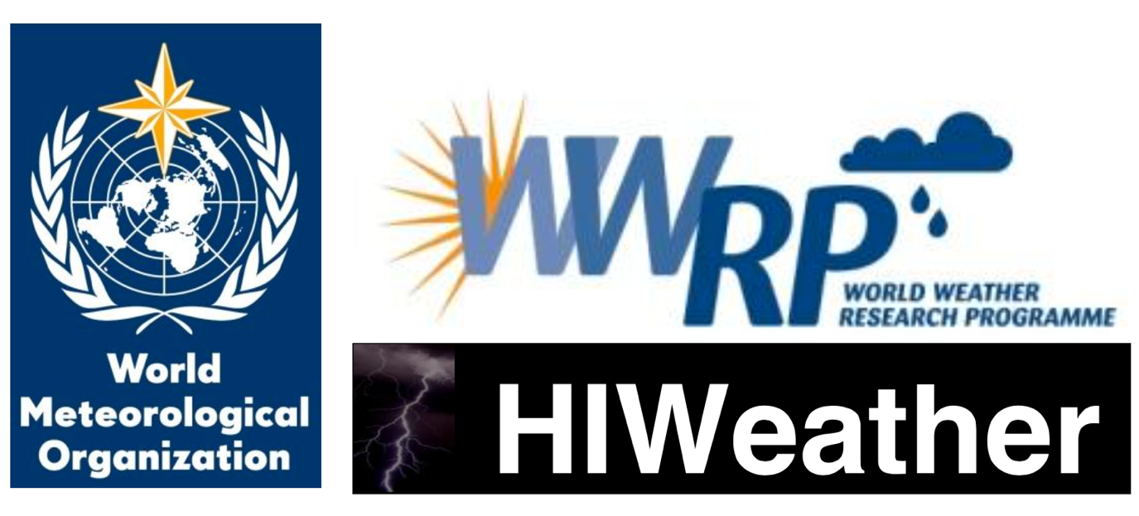

**White Paper on Health Linkages to HIWeather**

**Draft outline**

**Version: 22nd August 2017**

Table of contents

Figures and tables 3

1. Introduction 4

2. Structure of white paper 4

3. Decision-making processes in disaster action plans 5

1. Decision-making structure 5

2. Iterative management of decision-making structure 5

3. Identity of decision makers 6

4. Timeline of key decisions and processes 6

4. Key metrics to track health impacts of and vulnerability to disasters 8

Outlines of HIWeather focus areas 9

1. Urban Flood 9

Overview 9

Health impacts 9

Key processes made in preparedness and action plans 10

Key gaps in real-time monitoring, forecasting and alert capabilities 11

Key opportunities to develop or improve health relevant deliverables 11

Potential projects with improved forecasting 12

2. Wildfire 13

Overview 13

Health impacts 13

Key gaps in real-time monitoring, forecasting and alert capabilities 14

Key opportunities to develop or improve health relevant deliverables 14

Potential projects with improved forecasting 14

3. Localised Extreme Wind 15

Overview 15

Health impacts 15

Key gaps in real-time monitoring, forecasting and alert capabilities 15

Key opportunities to develop or improve health relevant deliverables 15

Potential projects with improved forecasting 15

4. Disruptive Winter Weather 16

Overview 16

Health impacts 16

Key gaps in real-time monitoring, forecasting and alert capabilities 16

Key opportunities to develop or improve health relevant deliverables 16

Potential projects with improved forecasting 16

5. Urban Heat Waves and Air Pollution 17

Overview 17

Health impacts 17

Key gaps in real-time monitoring, forecasting and alert capabilities 18

Key opportunities to develop or improve health relevant deliverables 18

Potential projects with improved forecasting 18

References 19

# Figures and tables

Figure 1. Potential flow of information between a lead body and other actors involved in heat action plans. 4

Figure 2. Communications plan for Ahmedabad Heat Action Plan 5

Figure 3. Schematic representation of time frames set out by WHO for implementing the core elements of a heat action plan.3 6

Table 1. Key focal areas of HIWeather and the outline in this report for each. 3

Table 2. Indicators from monitoring processes relevant to disasters. 7

# Introduction

Disaster globally since 1990 have caused the deaths of over 1.6 million people.1 High Impact Weather (HIWeather), a research activity within the World Weather Research Programme (WWRP), aims to improve extreme weather event forecasting, both in spatial resolution and predictive lead time. A significant beneficiary of HIWeather products could be decision makers in disaster early warning systems and emergency health care provision, who would be able to use improved forecasting techniques to better prepare for approaching extreme weather.

However, a significant knowledge gap exists in the HIWeather operation plan in terms of **where**, **when**, and **how** significant health care decisions are made. Further, missing is a detailed awareness of how much lead time is needed for health care decisions. If a significant goal of HIWeather is to improve health outcomes by successful utilisation of its products, the direction of improved HIWeather products must be steered by the awareness and knowledge of the nature of disaster-related health care decisions.

This white paper aims to give an exposition on the process by which health care decision makers build a timeline of required action. The report will be structured around each of the 5 areas of focus of HIWeather. **The logic of this approach is to begin with the desired health outcome improvements, and work systematically through the processes to identify where HIWeather products could be applied or tailored to assist the health sector.**

In this way, the selection and development of HIWeather products will be able to use health impacts at the heart its direction.

# Structure of white paper

The report begins with an overview of **key decision-making processes and timelines**, as well as **key metrics as trackers for disaster-related health outcomes**. It then outlines a series of health aspects relevant to each of the 5 HIWeather Focus areas (Table 1):

Table 1. Key focal areas of HIWeather and the outline in white paper for each area.

|  |  |
| --- | --- |
| HIWeather Focus Areas | Areas of Health Linkages to be outlined for each Focus Area |
| 1. urban flood 2. wildfire 3. localised extreme wind 4. disruptive winter weather 5. urban heat waves and air pollution | * **Health impacts.** Identify key health impacts related to each focus weather hazard area. * **Timeline of key decisions and processes.** Create timeline of decisions which need to be made by key decision makers. * **Key gaps in capabilities.** Identify key gaps in capabilities of forecasting (both in time and space) which can be improved upon to help decision makers make decisions.   **Key deliverables.** To improve capabilities of decision-makers to avert disaster-related deaths.  **Potential projects with improved forecasting.** Potential projects serving as focused health outcome-based research for HIWeather. |

# Decision-making processes in disaster action plans

## Decision-making structure

When disasters are forecast, it is important that a consolidated well-functioning decision-making process is in place to enable a smooth roll-out of emergency measures. At key points in the disaster-forecasting timeline, there are essential communication pathways between decision makers and practitioners. The Sendai Framework for Disaster Risk Reduction 2015-2030 makes strengthening disaster risk governance to manage disaster risk one of its four priorities for action.2

Figure 1 demonstrates the potential flow of information between decision-makers during consideration of activating a Heat Health Action Plan (HHAP)3. Figure 2 showcases an example, from the Ahmedabad Heat Action Plan, with more detail on the methods of communication between decision makers and practitioners.

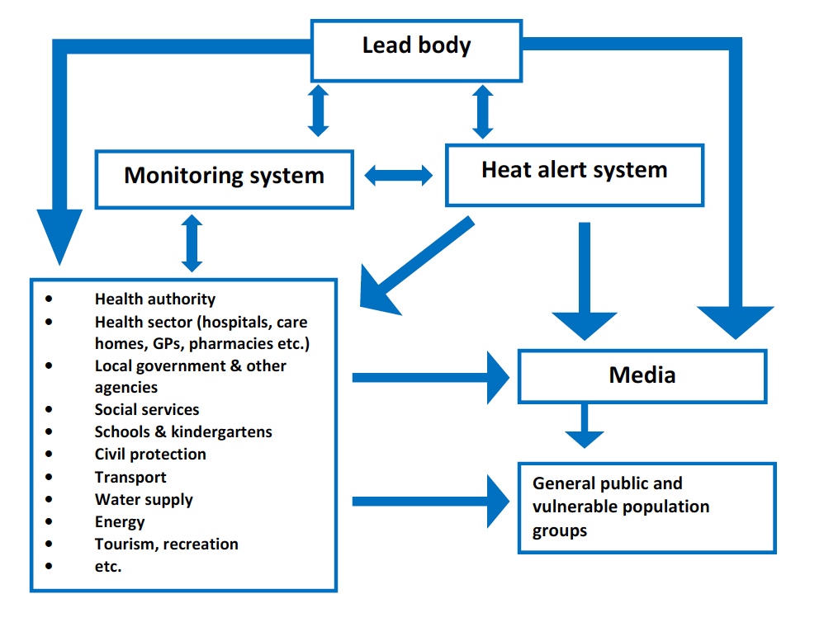

Figure 1. Potential flow of information between a lead body and other actors involved in heat action plans.

## Iterative management of decision-making structure

While it is important to set up a clear disaster management decision-making structure, it is crucial that these systems of management are reassessed over time, especially for when the structure is in place with a calendar year, if, for example with a heat wave action plan, the occurrence and management of disaster is only required at certain times of the year.4

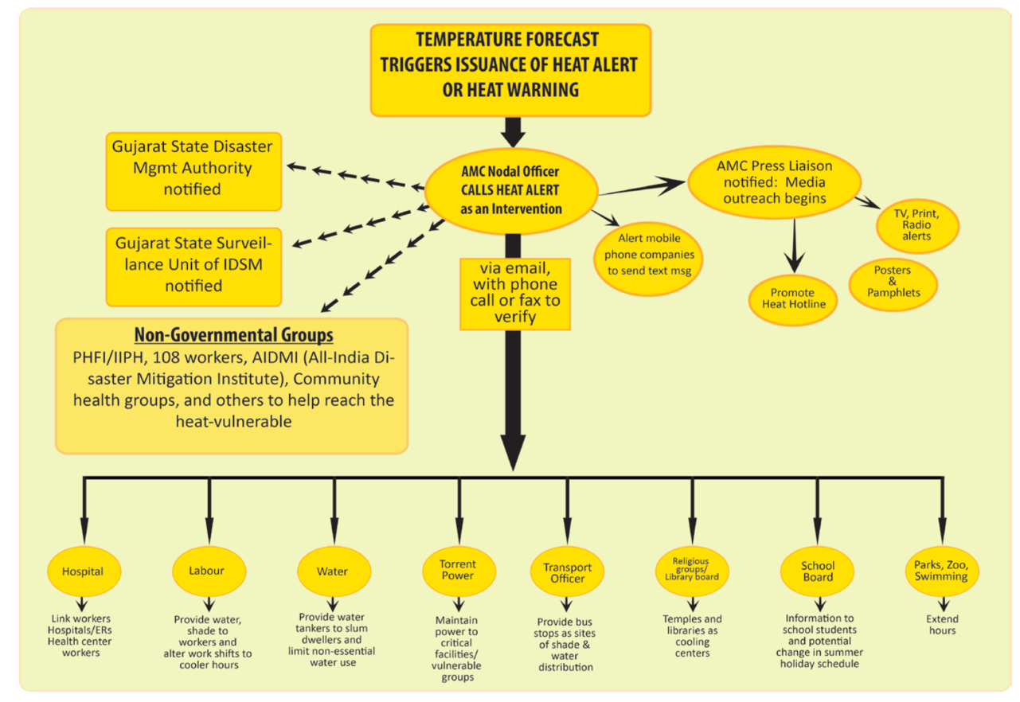

Figure 2. Communications plan for Ahmedabad Heat Action Plan

## Identity of decision makers

A decision maker will need key pieces of information in a timely manner to be able to make the correct calls for disaster planning. This includes, but is not exclusive to:

* National and local government
* Employers and private sector
* Social and advocacy groups
* Community groups
* Health practitioners

## Timeline of key decisions and processes

For the implementation of the above listed eight core elements, WHO recommends an

approach with five time frames5 :

* Longer-term development and planning
* Timely preparations before summer (pre-summer)
* Prevention during the summer
* Specific responses to periods of heat/heat waves
* Monitoring and evaluation

These timelines are depicted in (Figure 3):

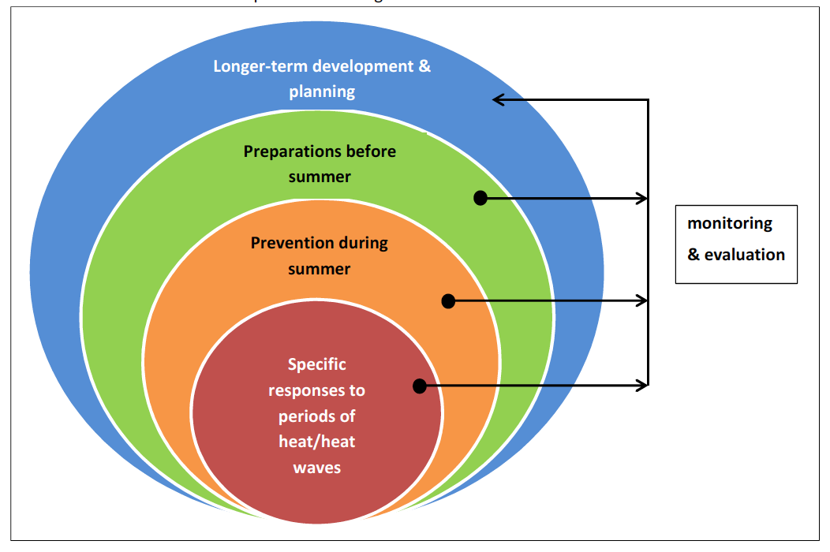

Figure 3. Schematic representation of time frames set out by WHO for implementing the core elements of a heat action plan.3

# Key metrics to track health impacts of and vulnerability to disasters

Disaster-related metrics provide a key quantification of the effect of disasters on mortality. Several monitoring processes include relevant indicators (Table 2):2,6,7

Table 2. Indicators from monitoring processes relevant to disasters.

|  |  |  |
| --- | --- | --- |
| **Monitoring process** | **Disaster(s) relevant** | **Indicator** |
| Lancet Countdown | 5 | 1.2 Health effects of heatwaves |
| 1,2,3,4,5 | Climate-resilient health infrastructure |
| Sendai Framework for Disaster Risk Reduction | 1,2,3,4,5 | A-1: Number of deaths and missing due to hazardous events per 100,000 |
| 1,2,3,4,5 | A-2 Number of deaths due to hazardous events |
| 1,2,3,4,5 | A-3 Number of missing due to hazard events |
| 1,2,3,4,5 | B-1 Number of affected people per 100,000 |
| 1,2,3,4,5 | B-2 Number of injured or ill people due to hazardous events |
| 1,2,3,4,5 | B-3 Number of people who left their places of residence due to hazardous events |
| 1,2,3,4,5 | B-3a Number of evacuated people due to hazardous events |
| 1,2,3,4,5 | B-3b Number of relocated people due to hazardous events |
| 1,2,3,4,5 | B-4 Number of people whose houses were damaged due to hazardous events |
| 1,2,3,4,5 | B-5 Number of people whose houses were destroyed due to hazardous events |
| 1,2,3,4,5 | B-6 Number of people who received food relief due to hazardous events. |
| Sustainable Development Goals | 1,2,3,4,5 | 1.5.1 Number of deaths, missing persons and persons affected by disaster per 100,000 people |
| WHO Climate and Health Country Profiles | 5 | Heat-related mortality |
| 1 | Exposure to flooding due to sea level rise |

# Outlines of HIWeather focus areas

## 1. Urban Flood

### Overview

Urban floods can arise from extreme thunderstorms (manifested as flash floods), or from river overflow. Both rapid rise and slow rise floods can have a significant impact on public health in an urban area.8 Between 1995 and 2015, 3,062 flood events were recorded9. Floods were responsible for the majority (56%) of natural disasters; affecting 2.3 billion people worldwide9. While the adverse health effects of flooding include direct impacts on human health, the pathways can be complicated and indirect.

### Health impacts

#### Immediate onset which can be informed by Public Weather Services

**Disruption to essential health care.** Treatment for serious illnesses, such as cancer, can be disrupted by flooding, due to transport infrastructure being knocked out for prolonged periods of time.10 Lack of availability of routine prescription medicines due to flooding may also impact health.11 Health care practitioners may also become overwhelmed by the increased demand for services.8

**Drowning or physical trauma.** Rapid rise floods can cause sudden changes to the environment, increasing the risk of drowning and injuries.12 Slow rise floods can also be deadly when there is a lack of preparedness.8 Injuries may include snake or other bites, and electrocution due to power lines.

**Facilitating Disease transmission.** Diseases can be spread from undisinfected groundwaters by the onset of flooding.13 Flooding of sanitation facilities, disruption to safe drinking water sources, poor hygiene, contact with contaminated surface waters, displacement and contact with other vectors such as rodents. Increased instances of cholera14, diarrheal diseases14, hepatitis A and E14, leptospirosis14, melioidosis15, respiratory infections16, and typhoid14 have been observed after floods in urban areas.

#### Impacts with longer-term onset related to flood events

**Malaria.** Epidemics in the wake of flooding in tropical regions can occur due to clogging of storm water drains, causing stagnant water to allow genesis of vectors of malaria.16,17

**Malnutrition.** Damage to infrastructure caused by flood, and disruption to food systems can cause appropriate food to be unavailable for prolonged periods, with children and the elderly particularly in developing countries vulnerable.18

**Psychological distress.** The mental health effects of a flood can last long after the flood itself, with reports of increased prevalence of psychological morbidity (including depression, anxiety, PTSD) in residents up to 1 year after floods, particularly if residents are displaced at short notice.19,20

### Key processes made in preparedness and action plans

#### Climate prediction (outside core interest of HIWeather but of interest to WCRP)

Long-term actions (years) i.e. long-term forecasts and projections:

**Adaptation of buildings and urban infrastructure in vulnerable flood plains.** A long-term preparedness action requires a detailed knowledge of potential flood plains and river overflows. Long-term adaptive action is important in both industrialised and developing nations to safeguard health of vulnerable communities.

**Flood barriers.** Building and planning using high-resolution modelling must be enacted long before a flood. Appropriate flood barriers require building to defend against a flood with a return period chosen after flood modelling.21

**Protection of drinking water sources.** Long-term decisions in urban areas include slow sand filters, which are also appropriate for large cities like London or Amsterdam, and routing permanent water supplies to avoid potential contamination.22 In developing countries, wells may still be the primary source of water, even in urban areas. Raising the head wall of a dug well, and providing a cover and outward-sloping concrete apron around it is one such way of providing additional security to the supply.22

#### Weather prediction (in core interest of HIWeather)

Mid-term actions (months) i.e. S2S forecasting:

**Drilling staff and citizens for urban flood scenarios.** Finding and training reliable staff for a flood scenario requires significant resources. In addition, holding discussions with vulnerable communities about action plans for floods is important to maximise the effectiveness of contingencies.22

Short-term actions (weeks, days, hours, minutes) i.e. nowcasting, short-term forecasting:

**Evacuation of low lying communities and health facilities.** Up to 3 days may be required for an effective evacuation of a densely-populated urban area.

**Providing alternative water sources.** Vulnerable communities may be isolated for days. As such, they will need to ensure they have drinking supplies for this requisite time. 15 litres per person, per day is a recommended amount, while 7 litres per person is classed as a minimum.22 This can be alleviated by supplying mobile purification units connected to the nearest untreated source22

**Provision of emergency food supplies.** Three days-worth of food to build up [ref= https://www.ready.gov/floods]

**SOPs for emergency medical transport services during floods.**

**Emergency shelter preparation for displaced communities.** Communities displaced may have to reside in temporary shelters. Like food and medical supplies, this may require days of advance preparation and knowledge of safe locations from flood.

### Key gaps in real-time monitoring, forecasting and alert capabilities

Key framework in HIWeather to follow?

### Key opportunities to develop or improve health relevant deliverables

**Clear messaging of probability, lead times and spatial scales.** Improving ‘believability’ of flood forecasts can and must be improved upon by having clearer messaging on the predictability and processes of weather systems. The trustworthiness of flood forecasts can increase the changes of appropriate action and response by a vulnerable population.23,24 Such ways to improve trustworthiness are diffuse, but include clearer explanation of uncertainty in forecasts, validation of hazards, among other aspects.

**High resolution hazard-exposure mapping** As flood hazard forecasts become more reliable at a higher resolution and longer timescales, hazard-exposure maps (similar to <https://coast.noaa.gov/floodexposure/#/splash)> with detailed overlay of vulnerable groups in flooding (e.g. the elderly, the poor)25 would help to provide targeted aid. This may rely on forecasts of flooding areas being made on the neighbourhood level (~1km resolution for overlay with gridded population datasets like <http://ec.europa.eu/eurostat/data/database)>.

**Vector-borne disease.** Advanced techniques are available for infectious disease mapping with the onset of precipitation, with a one month preparation lead time to adequately prepare medical treatment.26 Working with epidemiologists and infectious disease modellers more closely to understand their needs and wishes would greatly improve their ability to inform medical and emergency services.

**‘Warn on forecast’.** If the forecast skill is significantly improved in a case such as Hurricane Sandy to advance to further days in advance, essential preparations, especially for those less able to move from place-to-place, would be easier and less disruptive. This would require a consistent long-term forecast ensemble, as one of the main reasons Hurricane Sandy was so devastating was due to the conflicting information from competing model forecasts. [ref] This would be especially true for trapped members of the populations, for example those who are stuck in a house to ensure that they have an appropriate amount of food and/or remote medical treatment.

**Improved downscaling of flood forecasts to improve early warning systems.** A study experiment set in Japan demonstrated the benefits improving resolution of flood forecasts for early warning systems.27 This demonstrated that a dramatic improvement in flood forecast downscaling could have significant returns in the preparedness of a population from flood early warning systems.

**Tolerance levels of buildings and drainage systems.** Overflowing sewers and storm drains can lead to flooding and collections of stagnant water, which will both have significant health impacts.8 Under climate change and increasing urbanization, the maximum flows resulting from floods can and should influence design capacity for tolerance of urban storm water. Designing the appropriate drainage system in urbanized areas will depend upon hydro-meteorological characteristics.28 Predictability of long-term maximum estimated flows is therefore an important input of future urban design.

**Preparedness for after the flood** Hurricane Sandy failures in the post-hurricane flood show that more understanding is required by authorities into how the flood will affect infrastructure in the weeks after the flood itself. Improving modelling of water flows after the flood will result in better infrastructure planning, potentially saving many more lives, and certainly avoiding prolonged distress by a population of displacement without knowledge of return.

### Potential projects with improved forecasting

**CHECK section 4.4 in HIWeather document**

**Afghan flood warning**: https://public.wmo.int/en/media/news/afghanistan-meteorological-department-issues-first-flood-early-warning

**Working with food and medicine supply infrastructure in a developing country with early warning system to map pathways to vulnerable communities.** Vulnerable members of Pakistan’s population suffered malnutrition from the devastating floods of 2011.18 Working with authorities there, high resolution flood mapping with adequate lead times could aid planning for stockpiling of food.

**Project to create high resolution disease mapping simulations based on prediction of flood.** In early January 2015, devastating rains hit Malawi, resulting in massive floods across the country. This affected an estimated 638,000 people. There were 79 deaths associated with the floods. An outbreak of cholera resulted in 693 cases and 11 deaths. Advanced techniques are available for infectious disease mapping with the onset of precipitation, with a one month preparation lead time to adequately prepare medical treatment.26

**Long-term hospital infrastructure planning using high resolution flood modelling.** During the 2010 flood emergency in Pakistan, more than 500 hospitals and clinics were damaged or destroyed. High resolution extreme flood modelling could aid the planning of new flood-resistant hospitals and clinics, and help shore up existing treatment centres to enable them to continue to run.

**Education and workshops of key disaster relief stakeholders into understanding how forecasting of floods can be reported.** Often a key reason that appropriate action is not taken by a vulnerable population is that there is not sufficient belief that the flood warning will result in a flood. This is true even in industrialised countries like the USA. A key goal could be to work with practitioners who deploy resources in flood warnings to better understand what kind of information they need with regards to

## 2. Wildfire

### Overview

Uncontrolled spread of wildfire can originate from bush, vegetation, forest, heath and grass. Wildfires predominantly occur in countries with warmer climates, they have been known to occur from uncontrolled burning of vegetation in temperature climates such as in the UK.29 Many health impacts result from the inhalation of burnt organic material, but other direct effects are evident.

### Health impacts

#### Immediate onset which can be informed by Public Weather Services

**Burns.** Direct flame and thermal burns can result from a wildfire. The great increase in burns victims in a short time puts significant pressure on health care burns units, which can overwhelming these specialist centres.29

**Carbon monoxide poisoning.** This is mainly a risk to those who are in the immediate vicinity of the fire, such as firefighters. It can cause hypoxic injury, nervous system damage, and death.

**Eye irritation.** Those living close to the wild fires can experience eye irritation, as well as reduced general visibility due to ambient smoke, which can make vehicular accidents more likely.30 Corneal abrasions can also result from the eyes’ exposure to wildfire smoke.31

**Heat-induced illness.** Working in hot and humid conditions can cause many health issues (see ‘Urban Heat Waves and Pollution’). Firefighters can be particularly vulnerable when attempting to deal with the controlling the extent of the fires.

**Particulate matter inhalation.** Burning of organic material can produce several varieties of particulate matter. PM10 (particles under 10µm in diameter) can pass through the upper respiratory tract and are deposited in airways.29 PM2.5 (particles under 2.5 µm in diameter) can penetrate even deeper into the lungs and deposited where gaseous exchange takes place.29 Short-term exposure leads to increases in hospital admissions for respiratory conditions.32 Exposure to particulate matter will cause long-term health problems, and is a known risk factor for cardiopulmonary and lung cancer mortality.33,34

**Respiratory complications.** Breathing in bushfire smoke will exacerbate breathing problems for both children and adults. [ref]

#### Impacts with longer-term onset related to wildfire events

**Psychological distress.** Wildfires can cause the complete destruction of homes and livelihoods. This in turn can lead to depression, anxiety, and PTSD.35

**Water and land contamination.** Large concentrations heavy metals (such as arsenic, cadmium, copper, and lead) have been found deposited in soil from ash debris after a wildfire, which can cause various long-term health effects.36

### Key gaps in real-time monitoring, forecasting and alert capabilities

### Key opportunities to develop or improve health relevant deliverables

### Potential projects with improved forecasting

Example of Manitoba, Canada.

## 3. Localised Extreme Wind

### Overview

37

Health impacts

#### Immediate onset which can be informed by Public Weather Services

**Injuries from debris.** Buildings and trees

**Road accidents.**

**Sea spray.**

#### Impacts with longer-term onset related to extreme wind events

**Psychological distress.**

### Key gaps in real-time monitoring, forecasting and alert capabilities

### Key opportunities to develop or improve health relevant deliverables

### Potential projects with improved forecasting

## 4. Disruptive Winter Weather

### Overview

Health impacts

#### Immediate onset which can be informed by Public Weather Services

#### Impacts with longer-term onset related to disruptive winter weather events

### Key gaps in real-time monitoring, forecasting and alert capabilities

### Key opportunities to develop or improve health relevant deliverables

### Potential projects with improved forecasting

## 5. Urban Heat Waves and Air Pollution

### Overview

A heat wave, or extreme hot weather that lasts for several days, has no standard definition.38 However they are reasonably defined, they have a significant impact on society and are associated with a rise in morbidity and mortality.39 The impact of heat waves on human health can be catastrophic, as seen in the tens of thousands of excess deaths recorded in Europe during the summer of 2003,40 the Russian Federation in 2010, and in India in 2010.41 In industrialised countries, heat waves are responsible for deaths than other disasters, with 76% of weather-related disasters due to extreme temperatures between 1995-2015.9 Exposure to dangerous heat waves is forecast to increase under climate change over the current century.42

Those living in urban areas may also experience an amplified heat wave, as the urban heat island phenomenon can increase temperatures significantly compared with the surrounding non-urban area.43

Exposure to UV-rays can be increased during extreme heat.

Air pollution is characterized by a contamination of the indoor or outdoor (ambient) environment by any agent that modifies natural characteristics of the atmosphere. This definition includes aerosols and particulate matter, divided broadly into PM10 and PM2.5. Air pollution is thought to act as an aggravating factor on the health effects of heat waves.44,45 As such, it is important to consider air quality levels when considering the impact of a heat wave on a vulnerable population.

Ozone concentration is also thought to be an adverse modifier on mortality during extreme heat.46

### Health impacts

#### Immediate onset which can be informed by Public Weather Services

**Cerebrovascular accidents.** A stroke is caused by coagulation of blood in the brain, and studies have suggested that the blood of heat stressed individuals coagulates more readily..47

**Harvesting.** When already terminally ill members of a population are exposed to extreme heat, their deaths can be brought forward in time by a few weeks.48

**Heat edema.** Manifests itself as soft tissue swelling in those who are less acclimatised to heat being experienced.49 Cramps are more likely when exercising in hot and humid environments, but especially during exercise.50

**Heat exhaustion.** Common symptoms include headache, dizziness, goose flesh, nausea, vomiting, diarrhoea, irritability, and loss of coordination.50

**Heat rash.** Also known as ‘prickly heat’ or ‘milaria rubra’, heat rash results from sweating which saturates the skin surface, clogging the sweat ducts.49

**Heat stroke.** Clinically defined as when the body’s core temperature is at least 40.6C.51 A life-threatening condition, with a severe elevation of body temperature with central nervous system dysfunction that often includes combativeness, delirium, seizures, and coma.52

**Heat syncope.** Fainting from heat due to elevated body temperature.Syncope can indicate that someone is undergoing heat stroke.50

**Severe dehydration.** Profuse sweating can occur during a heat wave episode. This can lead to dehydration, which depletes electrolytes and causes sodium losses.50

#### Impacts with longer-term onset related to heat wave and air pollution events

### Key gaps in real-time monitoring, forecasting and alert capabilities

### Key opportunities to develop or improve health relevant deliverables

### Potential projects with improved forecasting

# References

1 European Commission. Science for Disaster Risk Management 2017. 2017 http://drmkc.jrc.ec.europa.eu/.

2 UNISDR. Sendai Framework for Disaster Risk Reduction 2015 - 2030. *Third World Conf Disaster Risk Reduction, Sendai, Japan, 14-18 March 2015* 2015; : 1–25.

3 Recommendations for Action Heat: Action Plans to protect human health. *Bundesministerium für Umwelt, Naturschutz, Bau und Reakt* 2017; : 1–32.

4 Hess JJ, Ebi KL. Iterative management of heat early warning systems in a changing climate. Ann. N. Y. Acad. Sci. 2016; : 21–30.

5 Matthies F, Bickler G, Marin N, Hales S. Heat–health action plans. *WHO Eur* 2008; : 45.

6 Watts N, Adger WN, Ayeb-Karlsson S, *et al.* The Lancet Countdown: tracking progress on health and climate change. *Lancet* 2017; **389**: 1151–64.

7 World Health Organization. Climate and Health Country Profiles 2015. 2015.

8 Hajat S, Ebi KL, Kovats RS, Menne B, Edwards S, Haines A. The human health consequences of flooding in Europe: A review. *Extrem Weather Events Public Heal Responses* 2005; : 185–96.

9 UNISDR, CRED. The human cost of weather-related disasters 1995-2015. *UNISDR Publ* 2015; **1**: 30.

10 Bennet G. Bristol floods 1968. Controlled survey of effects on health of local community disaster. *Br Med J* 1970; **3**: 454–8.

11 Ochi S, Hodgson S, Landeg O, Mayner L, Murray V. Disaster-Driven Evacuation and Medication Loss: a Systematic Literature Review. *PLoS Curr* 2014; : 1–24.

12 French J, Ing R, Von Allmen S, Wood R. Mortality from flash floods: a review of national weather service reports, 1969-81. *Public Health Rep* 1983; **98**: 584–8.

13 Miettinen IT, Zacheus O, Bonsdorff C-H von, Vartiainen T. Waterborne epidemics in Finland in 1998-1999. *Water Sci Technol* 2001; **43**: 67–71.

14 Watson JT, Gayer M, Connolly MA. Epidemics after Natural Disasters. *Emerg Infect Dis* 2007; **13**: 1–5.

15 Munckhof WJ, Mayo MJ, Scott I, Currie BJ. Fatal human melioidosis acquired in a subtropical australian city. *Am J Trop Med Hyg* 2001; **65**: 325–8.

16 Baqir M, Sobani ZA, Bhamani A, *et al.* Infectious diseases in the aftermath of monsoon flooding in Pakistan. *Asian Pac J Trop Biomed* 2012; **2**: 76–9.

17 Srivastava A, Nagpal BN, Saxena R, *et al.* Malaria epidemicity of Mewat region, District Gurgaon, Haryana, India: A GIS-based study. *Curr Sci* 2004; **86**: 1297–303.

18 Brabant M. Six months after floods struck, malnutrition hits hard in affected areas of Pakistan. UNICEF. 2011. https://www.unicef.org/emergencies/pakistan_57553.html.

19 Munro A, Kovats RS, Rubin GJ, *et al.* Effect of evacuation and displacement on the association between flooding and mental health outcomes: a cross-sectional analysis of UK survey data. *Lancet Planet Heal* 2017; **1**: e134–41.

20 Waite TD, Chaintarli K, Beck CR, *et al.* The English national cohort study of flooding and health: cross-sectional analysis of mental health outcomes at year one. *BMC Public Health* 2017; **17**: 129.

21 Dawson RJ, Hall JW, Bates PD, Nicholls RJ. Quantified Analysis of the Probability of Flooding in the Thames Estuary under Imaginable Worst-case Sea Level Rise Scenarios Quantified Analysis of the Probability of Flooding in the Thames Estuary under Imaginable Worst-case Sea Level Rise Scenarios. *Int J Water Resour Dev* 2007; **21**: 577–91.

22 Wisner B, Adams J. Chapter 7. Water supply. *Environ Heal Emergencies Disasters a Pract Guid* 2003; : 92–126.

23 Morss RE, Mulder KJ, Lazo JK, Demuth JL. How do people perceive, understand, and anticipate responding to flash flood risks and warnings? Results from a public survey in Boulder, Colorado, USA. *J Hydrol* 2016; **541**: 649–64.

24 Lazo JK, Bostrom A, Morss RE, Demuth JL, Lazrus H. Factors Affecting Hurricane Evacuation Intentions. *Risk Anal* 2015; **35**: 1837–57.

25 Rufat S, Tate E, Burton CG, Maroof AS. Social vulnerability to floods: Review of case studies and implications for measurement. *Int J Disaster Risk Reduct* 2015; **14**: 470–86.

26 Pasetto D, Finger F, Rinaldo A, Bertuzzo E. Real-time projections of cholera outbreaks through data assimilation and rainfall forecasting. Adv. Water Resour. 2016; **0**: 1–12.

27 Yu W, Nakakita E, Jung K. Flood Forecast and Early Warning with High-Resolution Ensemble Rainfall from Numerical Weather Prediction Model. *Procedia Eng* 2016; **154**: 498–503.

28 Chen CF, Liu CM. The definition of urban stormwater tolerance threshold and its conceptual estimation: An example from Taiwan. *Nat Hazards* 2014; **73**: 173–90.

29 Finlay SE, Moffat A, Gazzard R, Baker D, Murray V. Health impacts of wildfires. *PLoS Curr* 2012; : 1–23.

30 Hänninen OO, Salonen RO, Koistinen K, Lanki T, Barregard L, Jantunen M. Population exposure to fine particles and estimated excess mortality in Finland from an East European wildfire episode. *J Expo Sci Environ Epidemiol* 2009; **19**: 414–22.

31 Shustermann D, Kaplan JZ, Canabarro C. Immediate Health-Effects of an Urban Wildfire. *West J Med* 1993; **158**: 133–8.

32 Morgan G, Sheppeard V, Khalaj B, *et al.* Effects of bushfire smoke on daily mortality and hospital admissions in Sydney, Australia. *Epidemiology* 2010; **21**: 47–55.

33 Pope III CA, Burnett RT, Thun MJ, Calle EE, Krewski D, Thurston GD. Lung Cancer, Cardiopulmonary Mortality, and Long-term Exposure to Fine Particulate Air Pollution. *J Am Med Assoc* 2002; **287**: 1132–41.

34 Katsouyanni K, Touloumi G, Spix C, *et al.* Short-term effects of ambient sulphur dioxide and particulate matter on mortality in 12 European cities: results from time series data from the APHEA project. Air Pollution and Health: a European Approach. *BMJ* 1997; **314**: 1658–63.

35 American Psychological Association. Recovering From Wildfires. 2011. http://www.apa.org/helpcenter/wildfire.aspx.

36 Wittig V, Williams S, DuTeaux SB. Public Health Impacts of Residential Wildfires: Analysis of Ash and Debris from the 2007 Southern California Fires. *Epidemiology* 2008; **19**: S207.

37 Goldman A, Eggen B, Golding B, Murray V. The health impacts of windstorms: A systematic literature review. *Public Health* 2014; **128**: 3–28.

38 Robinson PJ. On the definition of a heat wave. *J Appl Meteorol* 2001; **40**: 762–75.

39 Baccini M, Kosatsky T, Analitis A, *et al.* Impact of heat on mortality in 15 European cities: attributable deaths under different weather scenarios. *J Epidemiol Community Heal* 2011; **65**: 64–70.

40 Fouillet A, Rey G, Laurent F, *et al.* Excess mortality related to the August 2003 heat wave in France. *Int Arch Occup Environ Health* 2006; **80**: 16–24.

41 Azhar GS, Mavalankar D, Nori-Sarma A, *et al.* Heat-related mortality in India: Excess all-cause mortality associated with the 2010 Ahmedabad heat wave. *PLoS One* 2014; **9**. DOI:10.1371/journal.pone.0091831.

42 Jones B, O’Neill BC, McDaniel L, McGinnis S, Mearns LO, Tebaldi C. Future population exposure to US heat extremes. *Nat Clim Chang* 2015; **5**: 652–5.

43 Tan J, Zheng Y, Tang X, *et al.* The urban heat island and its impact on heat waves and human health in Shanghai. *Int J Biometeorol* 2010; **54**: 75–84.

44 Shaposhnikov D, Revich B, Bellander T, *et al.* Mortality related to air pollution with the moscow heat wave and wildfire of 2010. *Epidemiology* 2014; **25**: 359–64.

45 Fischer PH, Brunekreef B, Lebret E. Air pollution related deaths during the 2003 heat wave in the Netherlands. *Atmos Environ* 2004; **38**: 1083–5.

46 Filleul L, Cassadou S, Médina S, *et al.* The relation between temperature, ozone, and mortality in nine French cities during the heat wave of 2003. *Environ Health Perspect* 2006; **114**: 1344–7.

47 Semenza JC, McCullough JE, Flanders WD, McGeehin MA, Lumpkin JR. Excess hospital admissions during the July 1995 heat wave in Chicago. *Am J Prev Med* 1999; **16**: 269–77.

48 Le Tertre A, Lefranc A, Eilstein D, *et al.* Impact of the 2003 heatwave on all-cause mortality in 9 French cities. *Epidemiology* 2006; **17**: 75–9.

49 Howe AS, Boden BP. Heat-related illness in athletes. *Am J Sports Med* 2007; **35**: 1384–95.

50 Beltran GW. Heat-related illness. *Emerg Med Serv Clin Pract Syst Overs Second Ed* 2015; **1**: 358–62.

51 R, Donoghue E, A, Graham M, M, Jentzen J, D, Lifschultz B, Luke JL. Criteria for the diagnosis of heat-related deaths: National Association of Medical Examiners. Position paper. National Association of Medical Examiners Ad Hoc Committee on the Definition of Heat-Related Fatalities. *Am J Forensic Med Pathol* 1997; **18**.

52 Leon LR, Bouchama A. Heat stroke. *Compr Physiol* 2015; **5**: 611–47.

53 Fouillet A, Rey G, Wagner V, *et al.* Has the impact of heat waves on mortality changed in France since the European heat wave of summer 2003? A study of the 2006 heat wave. *Int J Epidemiol* 2008; **37**: 309–17.